Steps to Deploy a WAS 7 Servlet within Eclipse, given that you have the project setup as per our recommendations (i.e. Eclipse Helios, WAS7 Server installed locally, and WAS7 plugin installed within eclipse)

Prerequisites:

1. Check out the WICIMiddlewareBroker2 project from SVN as a DYNAMIC WEB PROJECT within eclipse.
2. Create a Server in the Servers view. Ensure that it is an IBM Websphere 7 server. The server configuration is in another document, as was previously discussed weeks ago.
3. Right-click on server name in Servers view, select “Administration”, then “Run Administrative Console”. You will see the view below.

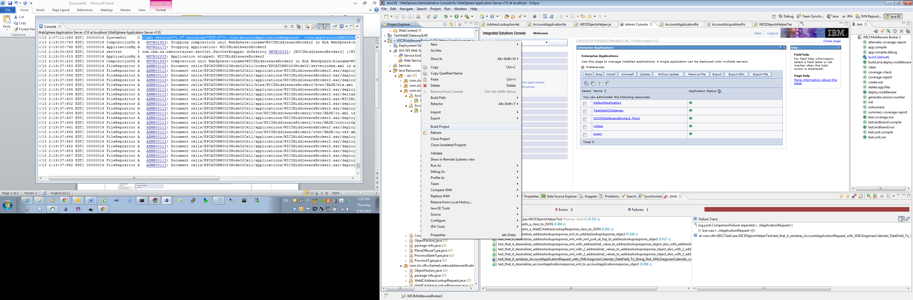

Step 1: Once project is checked out, right-click on project, “Build Project”

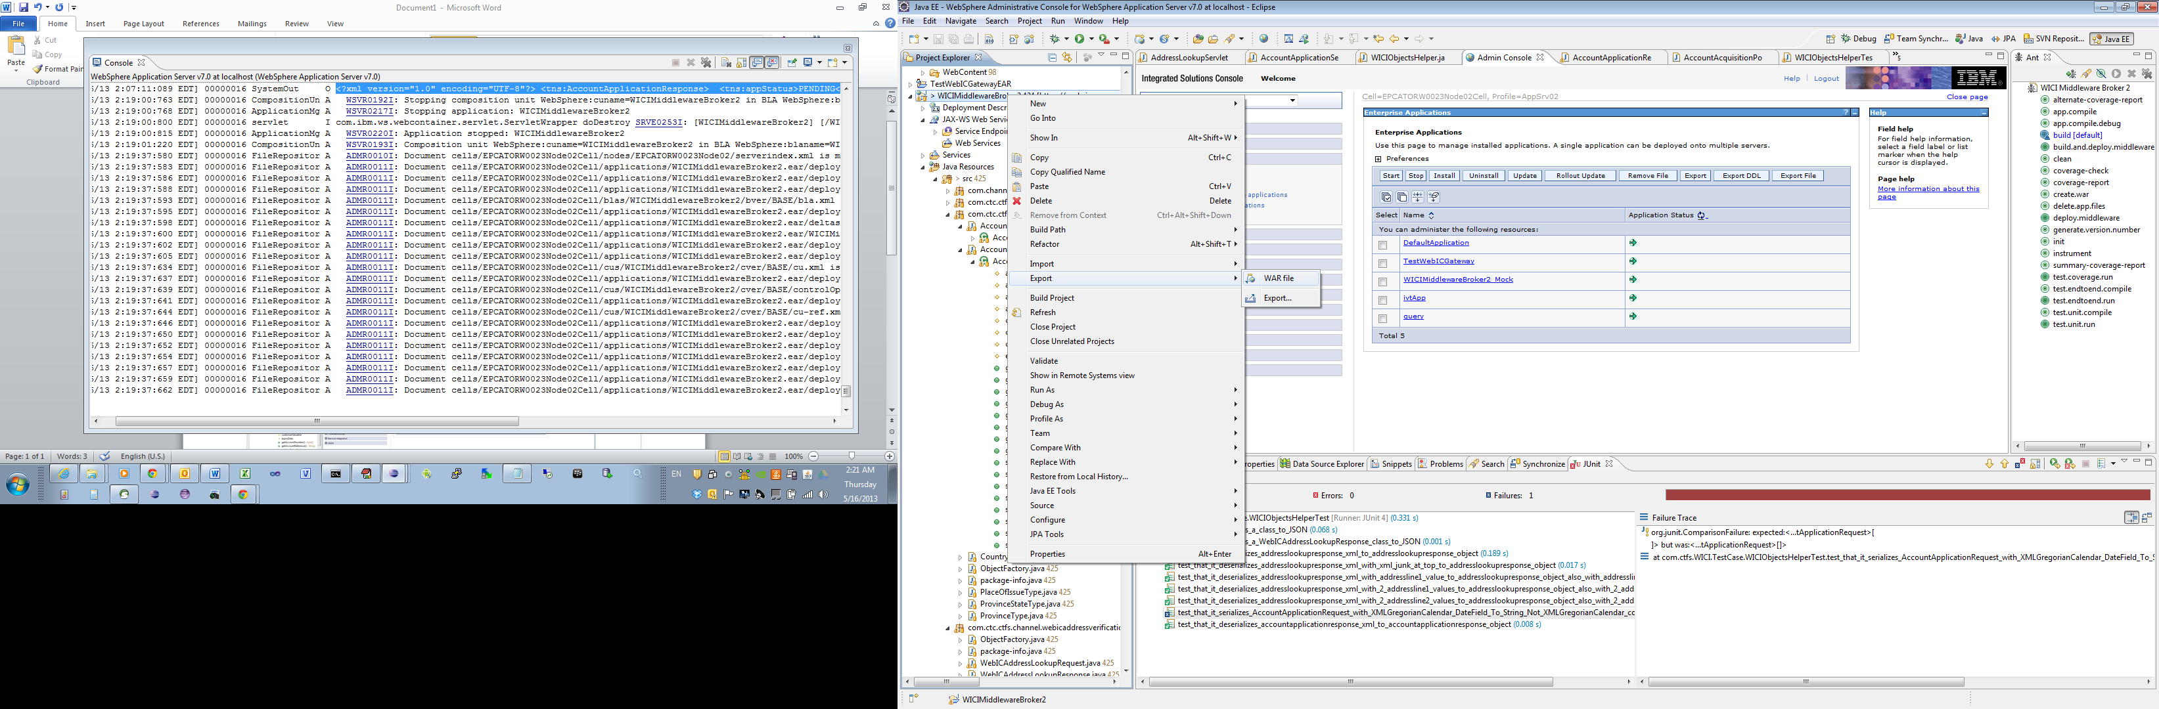

Step 2: Right-click project, select Export -> WAR file

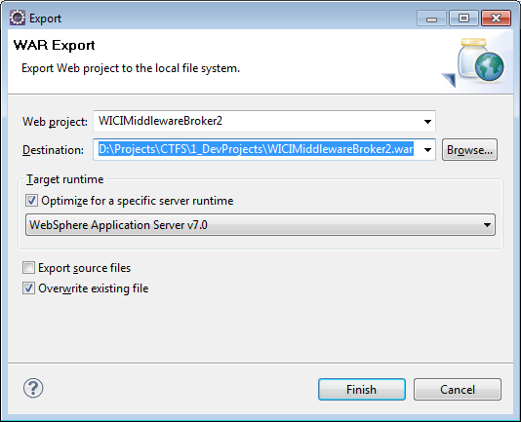

Step 3: Type in a suitable location and filename.

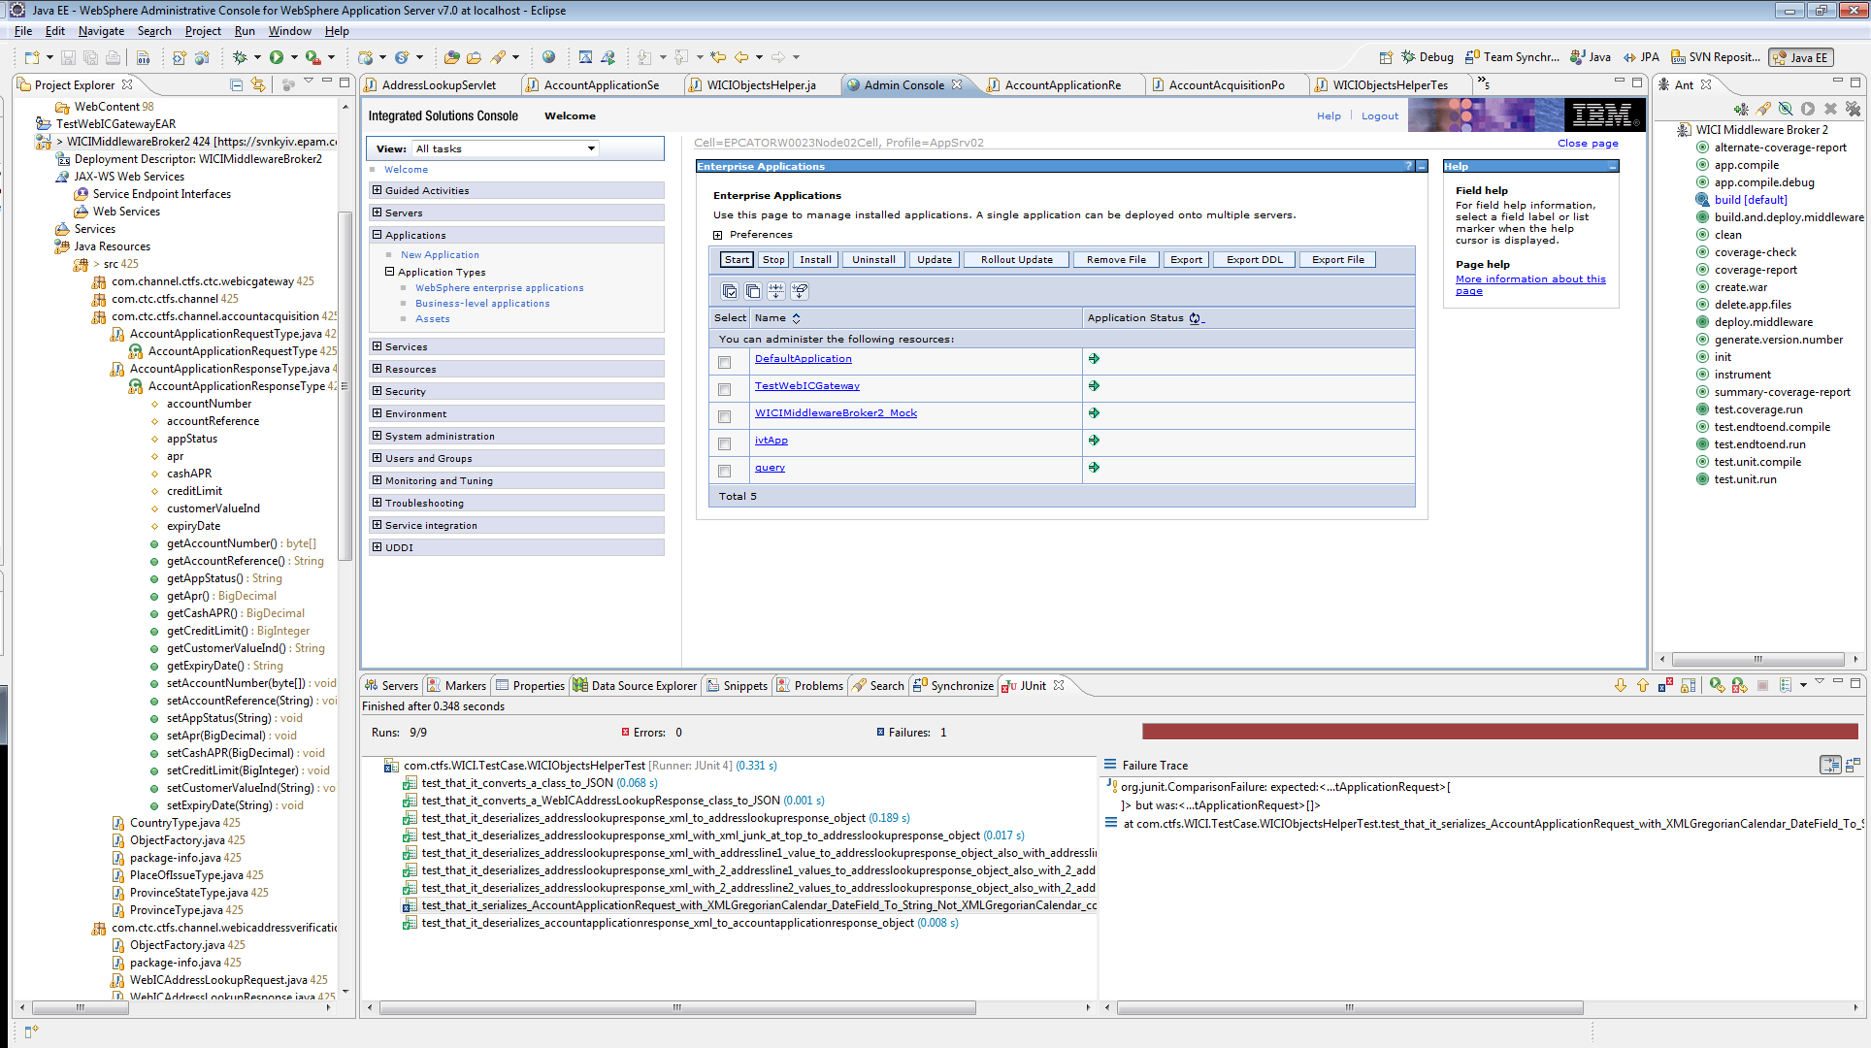

Step 4: Click “Install” in the Admin console.

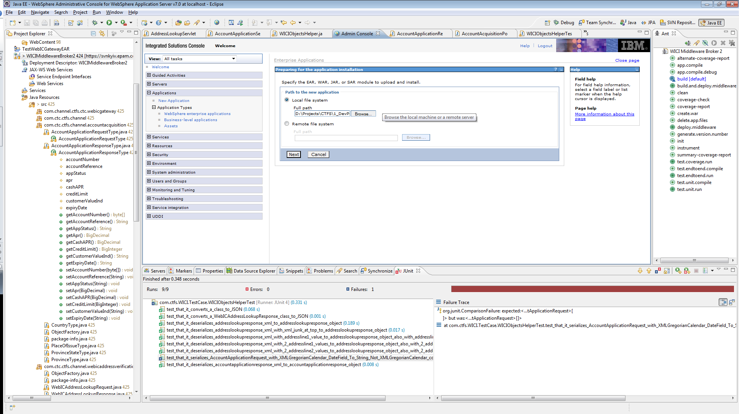

Step 5: Select Browse… and find the war file you created in step 3. Click next.

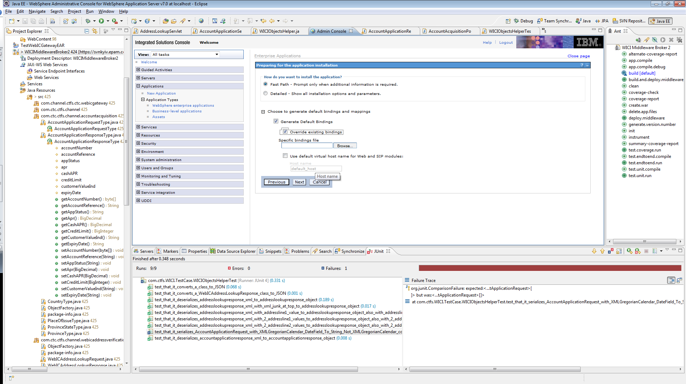

Step 6: Choose Fast Path (default). Choose “Generate Default Bindings” (optional), and “Override existing bindings”. Click next.

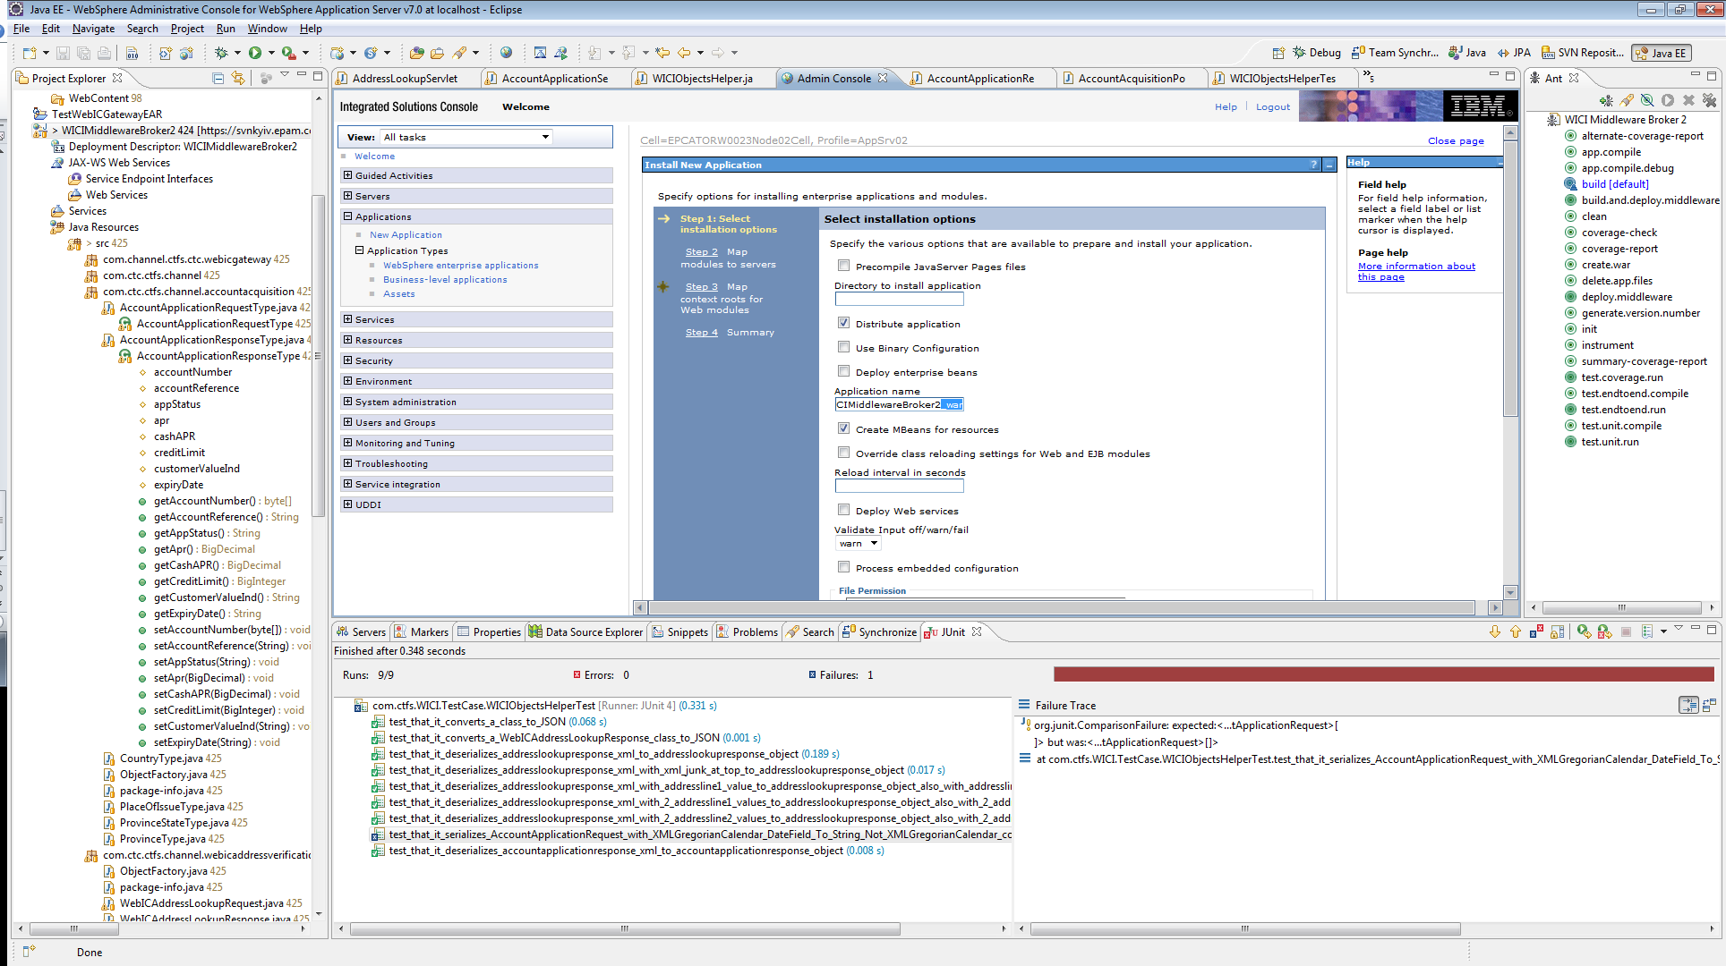

Step 7: Remove the “_war” from the Application name. Click next.

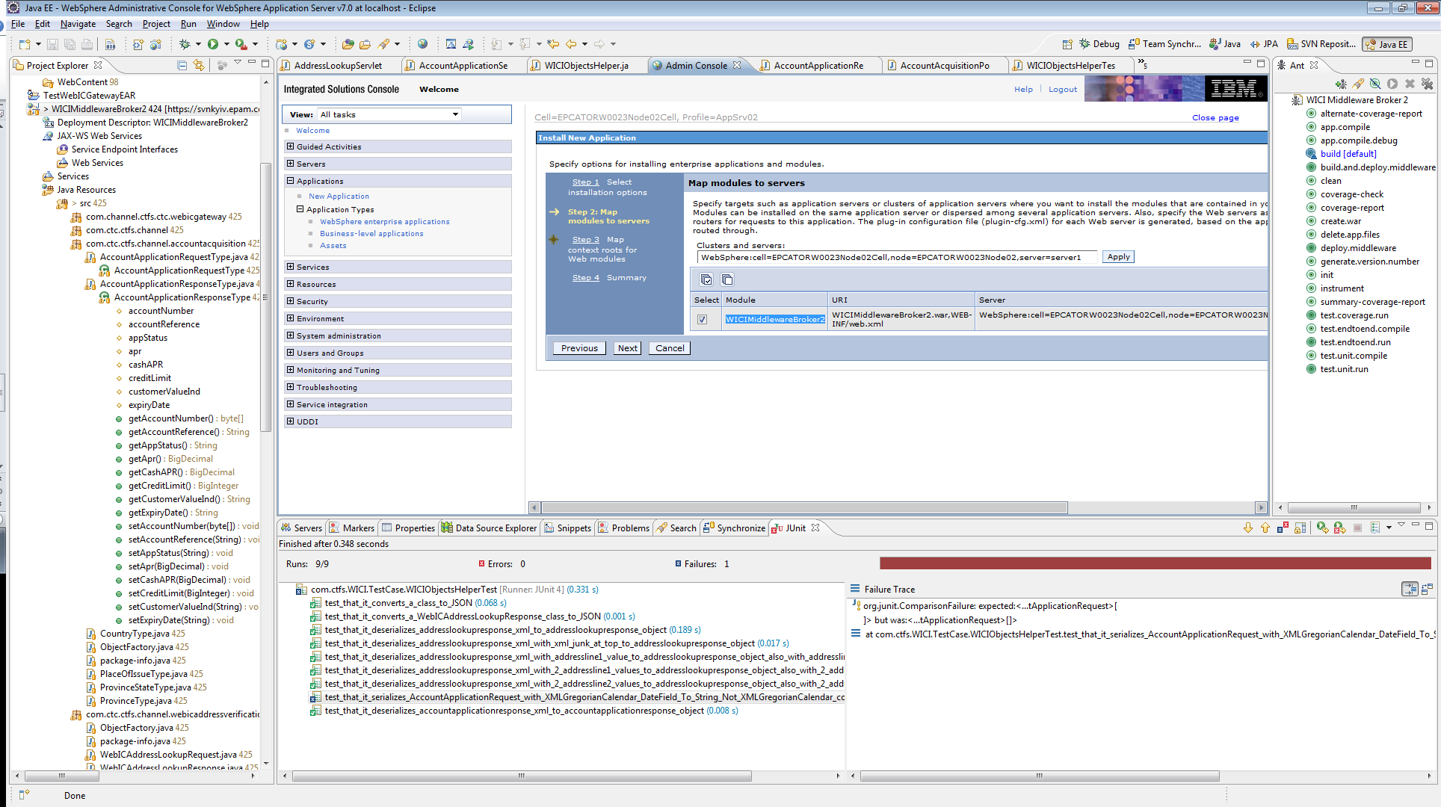

Step 8: Click the checkbox, double-click the name, then copy to clipboard (CTRL-C in windows). Click next.

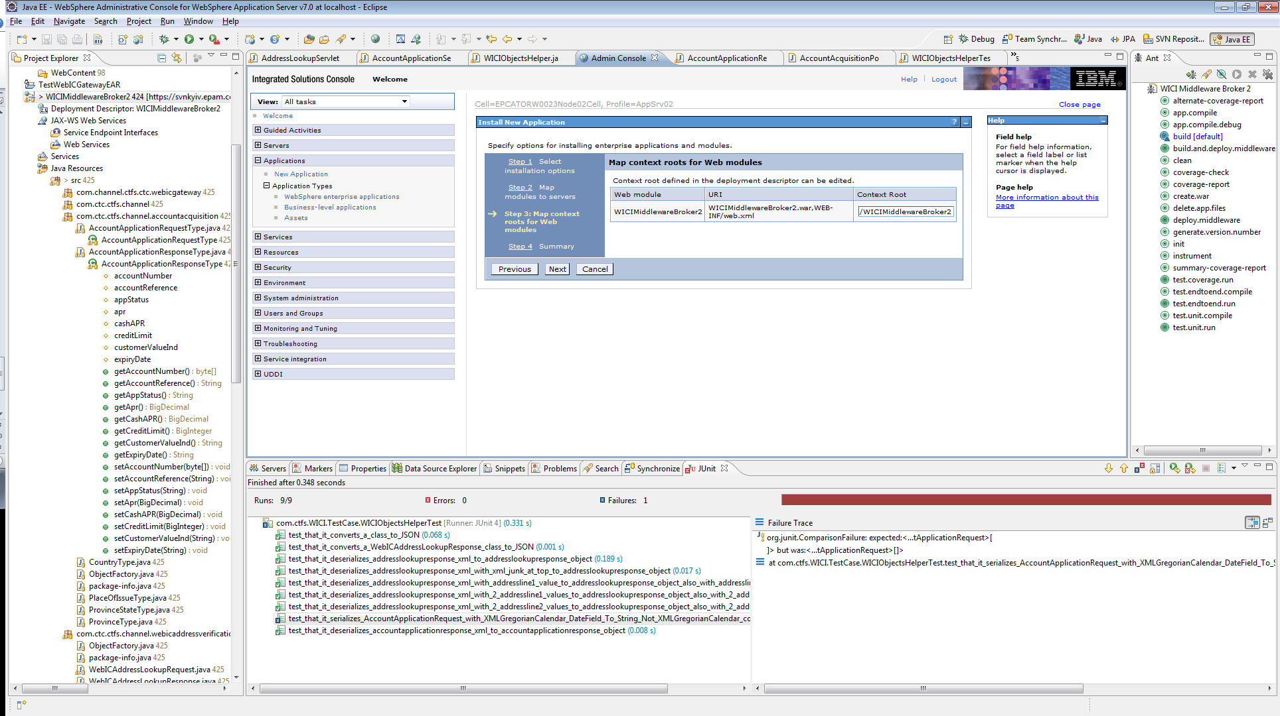

Step 9: Paste the name of the application. Click next.

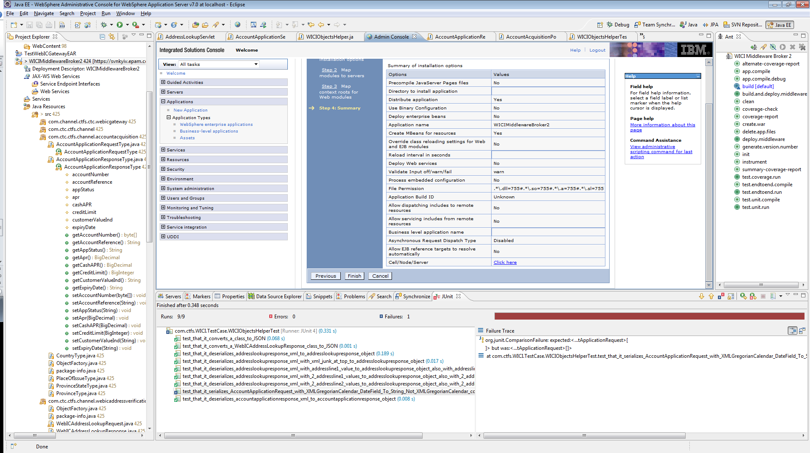

Step 10: Click finish.

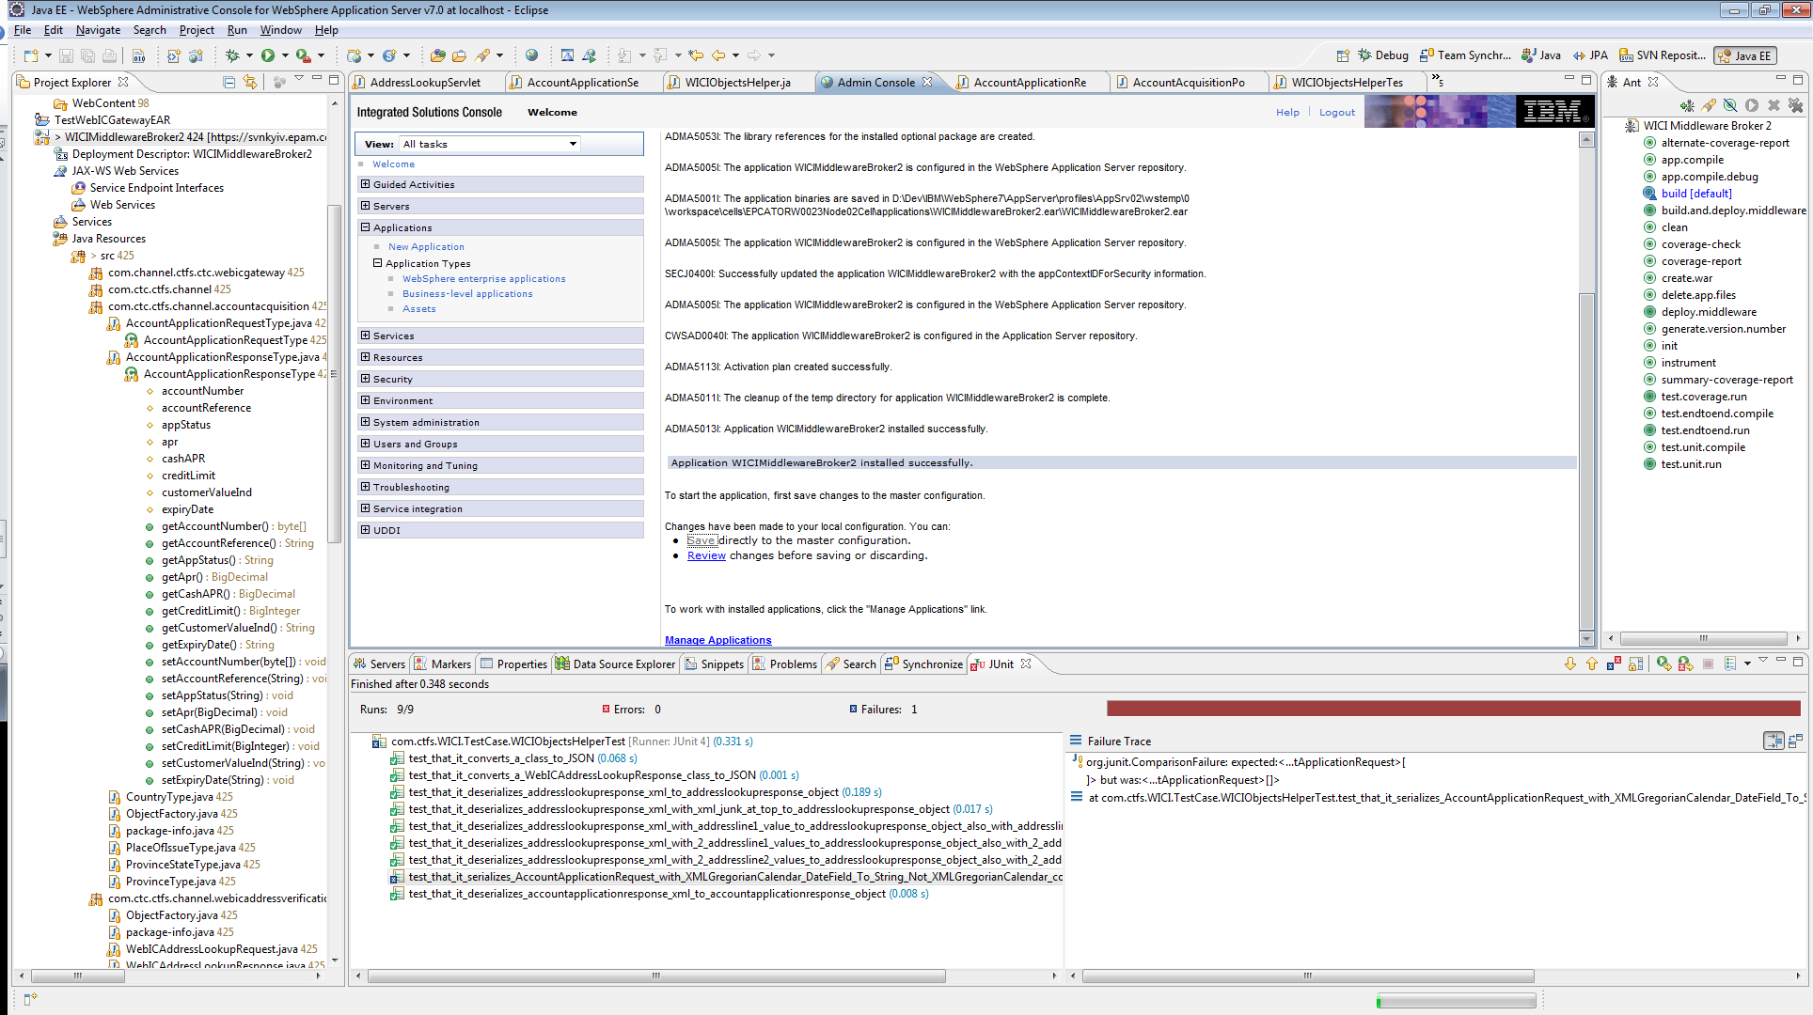

Step 11: Wait a bit, it will display some information indicating that it is installing the war file. Click save.

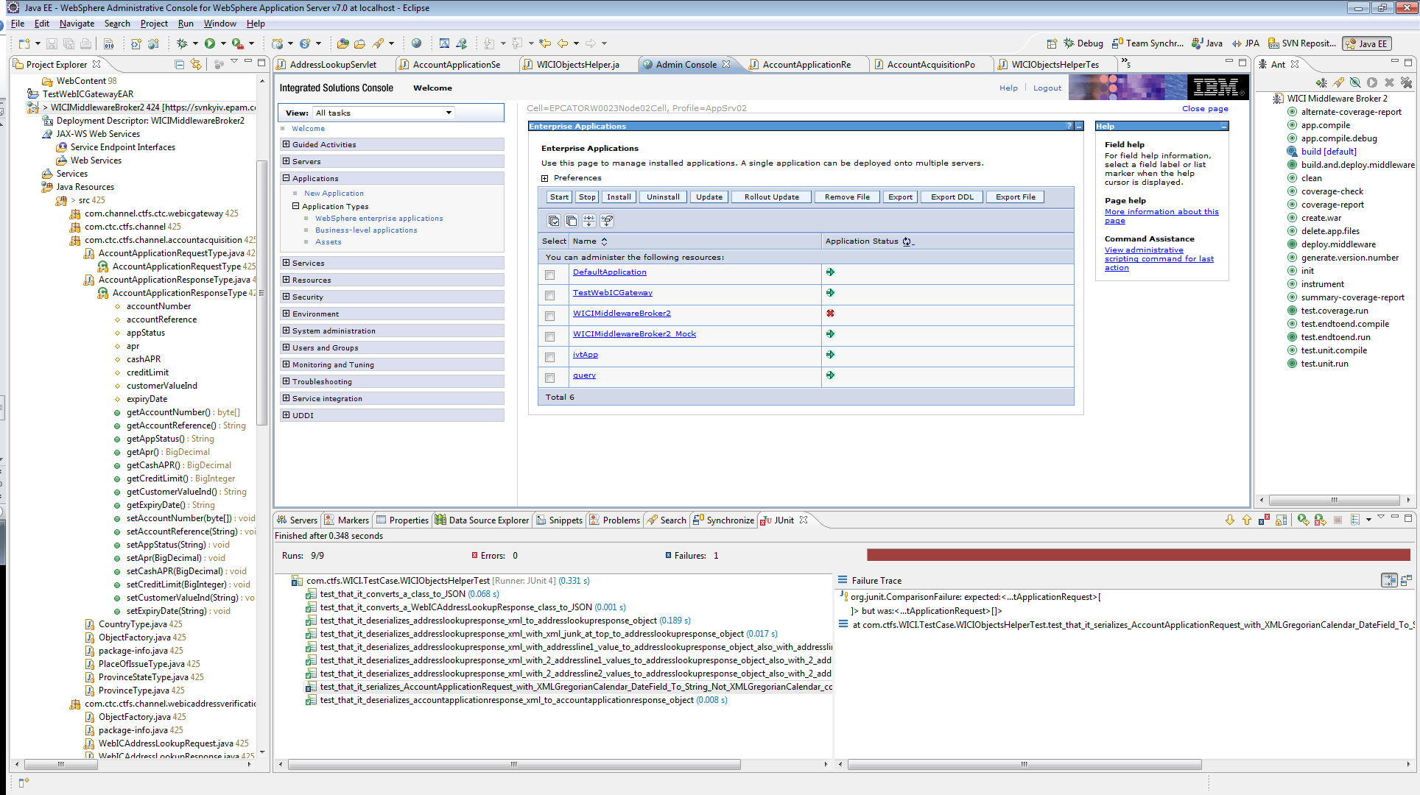

Step 12: You will see a red x at the “Enterprise Applications” screen. Click start.

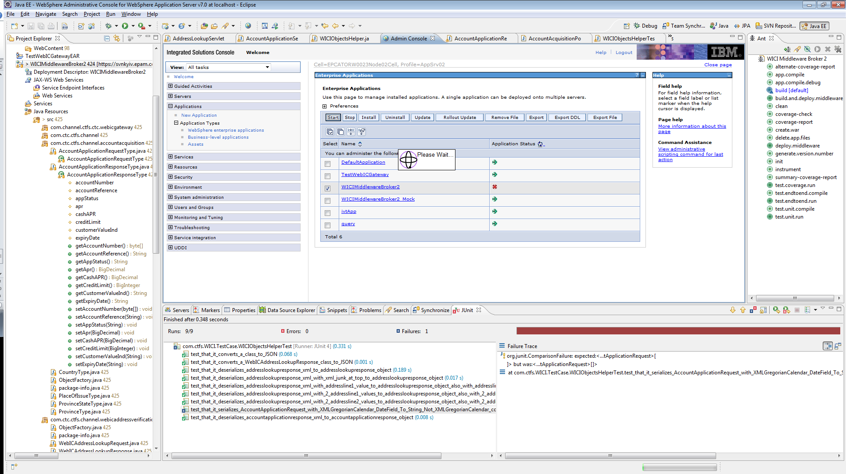

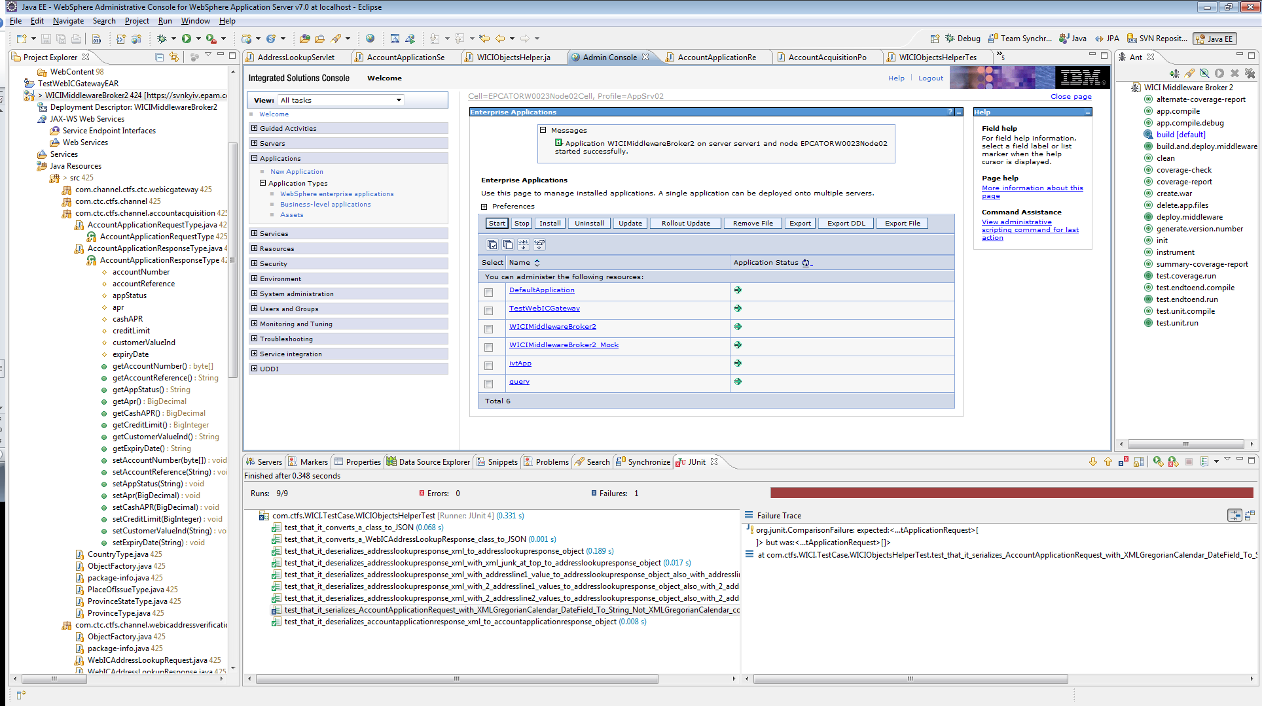

Step 13: Application is started. You can now test by hitting your local instance of WAS 7. On mine it is <http://localhost:9081/WICIMiddlewareBroker2/AccountApplicationServlet>